## Enabling significant public contribution to urban redesign with open-source 3D modeling software

Andrew Benjamin Likuski

Department of Urban and Environmental Policy and Planning

Tufts University

November, 2011

#### Abstract

This paper explores the potential of open-source software to empower the public to contribute persuasive streetscape redesigns that promote carfree space and modern, comprehensive transit systems. The author developed a software plugin named Rescape that works in conjunction with the popular free 3D modeling program, Google Sketchup. Rescape is open-source software (though Sketchup is not) that guides users through the process of performing a redesign of an existing urban space of their choice. It provides custom tools, including the ability to download and render road data for their area of choice, as well as a variety of tools to ease the layout of useful streetscape elements such as streetcar tracks, sidewalks, and trees that are aligned with the downloaded road data. Rescape enables users to quickly create the foundations of a realistic site redesign model that can then be augmented by Sketchup's built in tools and large collection of free 3D components. The software's ultimate goal is to help the public create and share ideas that advance carfree urban spaces with modern rail-based transit as the preferable solution to the current car-oriented allocation of public space. The author concludes that open-source urban redesign software is an important component for promoting better changes to the urban form than those advanced by today's planning processes.

Table of Contents

Abstract 2

Introduction 4

Goals of the Project 5

Motivations for a tool that promotes carfree urban spaces 6

Software and Literature Review 10

Organized Participation with Software 11

Impacts of public design contributions to redevelopment 19

Review of carfree urban space literature 21

A Description of Rescape's Functionality 22

Downloading Ways 24

Modifying Ways 27

Streetscape Design 29

Additional 3D Components and Streetscape Decoration 31

3D Buildings 33

Next steps planned for the software 34

Elevation changes and overpasses 34

Improvements to Downloading Ways 35

Improvements to Modifying Ways 35

Improvements to Streetscape Design 35

Adding Report Templates 37

Sharing 37

Implications for urban planning 38

References 40

# Introduction

Given the empirical evidence that carfree urban spaces and comprehensive transit promote a superior scale of livability and reduced environmental impact, how can such urban form be promoted? Improvements in software technology and ubiquitous Internet connectivity are transforming the way urban redevelopment proposals are visualized and vetted by the public and decision-makers. Using a combination of 3D virtual models and online communication forums, new technologies are giving professionals and independent contributors the opportunity to advocate substantial changes that were previously difficult to disseminate and present to the public and decision-makers. Among the most dramatic of these projects are those that promote the pedestrianization of business districts combined with the implementation of modern surface transit, a visualization so striking that it turns the focus away from traditional traffic circulation concerns and toward the opportunities created by the redevelopment. Thus far, however, the software that makes effective visualization of such projects possible has been inaccessible to the general public.

Sophisticated commercial urban modeling software now exists, but it is priced beyond the reach of most of the public and many professionals. There is also freely available 3D modeling software, but without built-in support for urban modeling. Is it possible to extend such software to offer carfree space and comprehensive transit advocates the ability to create credible redevelopment proposals for their neighborhoods, city centers, or transportation corridors? This thesis examines the urban design software that I have created as an extension of existing, freely available 3D modeling software. The software, called *Rescape*, is a plugin to the freely downloadable Google Sketchup. It enables users to redesign existing streets and their surroundings atop satellite images of any place in the world. Rescape makes layout of 3D streetscape components simple and relatively accurate to the street dimensions. The end goal of the software is a realistic 3D model of the proposed site redesign that can be shared with and discussed by the public.

# Goals of the Project

Rescape aims to assist in the visualization of urban redevelopments that favor carfree spaces and comprehensive transit (Figure 1). Users of the software are encouraged to redesign an area around an important activity center, whether it be a business district, transit station, or major street intersection. The 3D models that users create can effectively demonstrate improvements to a space as well as the movement of people and transit through it. Users are also encouraged to demonstrate their proposed improvements to the buildings surrounding the redeveloped space in cases where increased housing density or a greater variety of uses is needed.

Figure 1: A site redesign project by the author of Powder House Square in Somerville, Massachusetts that inspired the creation of Rescape.

I hope that in giving people the power to redesign their neighborhoods or city centers for carfree spaces and comprehensive transit, advocates will both accelerate the carfree cities movement and help bring credible plans to fruition by garnering populist excitement and optimism as well as serious attention from government and business interests. Rescape is accessible to anyone interested in doing a site redesign, with a learning curve similar to a word processor and no professional experience in urban design, planning, or landscape architecture necessary. The software is necessarily more of a “sketch” tool than a complex and complete urban design solution, but its output is nonetheless compelling.

By enabling creativity, the most intriguing plans may be shared with 3D visual cues, which are more attractive to discussion and publicity than written plans that are limited to 2D representations. Ultimately, Rescape will contribute a product that helps redevelopment advocates present alternatives to the small incremental improvements or outright mistakes that are typical of today's planning processes, or at least engender awareness of more significant long-term solutions. Incremental fixes like traffic calming and bus lanes could be phased out in favor of full transformations to the streetscape (significant carfree space and comprehensive transit) that are proportional to or exceed the efficacy and aesthetics of the best planning practices worldwide.

# Motivations for a tool that promotes carfree urban spaces

Rescape is based upon the premise that comprehensive public transportation accompanied by pedestrian-oriented urban form and amenities offers a higher quality-of-life than the status quo in car-centric urban areas. The premise could extend to suburban areas and towns where some or all of the built form was laid out prior to mass-motorization (i.e. prior to the 1920s) or in municipalities that are willing to explore major adjustments to their population density patterns. The potential quality-of-life improvements are easiest to demonstrate by first recognizing the negative attributes of car-centric design.

Cars evolved to solve the problem of point-to-point mobility between any two locations, but we have learned that offering the majority of people in an urban area this option has severe side effects. Streets cannot scale to accommodate mass-motorization without substantial sacrifice to the pedestrian environment, which is evident considering that a moving car takes up about a hundred times the space as a moving pedestrian (Alexander, Ishikawa, and Silverstein 1977, chap. 11), meaning the limited resource of public space in urban areas is disproportionately allocated to drivers. Point-to-point mobility has furthermore significantly diminished casual social interactions between community members by eliminating the need to walk to a public gathering area with local shops. This in turn has eliminated built-in daily exercise at the expense of public health, increased social isolation, and weakened the local economy.

Car use is perhaps the most environmentally detrimental activity performed by individuals, causing them to consume non-renewable fuels that give off harmful particulate and greenhouse gas emissions. The emergence of affordable electric cars will curtail emissions and engine derived noise pollution substantially, but it will not solve the aforementioned spacial, social, or physical health problems exacerbated by driving, nor will it decrease the intimidation and danger to other users of public places. Autonomously driven cars will in time address some of these issues by decreasing the need for parking (by functioning as taxis) and increasing safety, but they will do nothing to promote center-based development or community cohesion. Perhaps the most detrimental impact to the environment that is inherent to any type of car use is the sprawled land use patterns that cars create by shrinking distances. As travel times decrease, physical space requirements expand to accommodate low-density housing, requiring more road, parking, and utility allotments. The resulting sprawl encroaches on rural areas and natural space and eliminates the ability to live without a car.

Small carfree city centers and town squares in Europe, Asia and on the other continents show the beginnings of a more equitable, social, and environmentally sustainable way to use public space and right-of-way (Figure 2). (A list of carfree places worldwide was started by J.H. Crawford and is now hosted on wikipedia.org (Wikipedia Contributors 2011).). Unfortunately, citizens elsewhere cannot imagine how to transition to carfree cities, or cannot imagine them at all, since cars are ubiquitous in settled areas and are difficult to live without. Few planning and transportation professionals believe carfree development is practical or even desirable, despite the fact that successful models exist. The popular movement of New Urbanism, for example, seeks to rethink neighborhood design for higher livability but requires accommodation of cars, a concession that Register critiques as a bridge measure whose end goal will be forgotten (Congress for the New Urbanism 2011), (Register 2006, 122). Indeed, today's street calming measures and New Urbanist patterned developments offer little evidence of a future with significant carfree spaces.

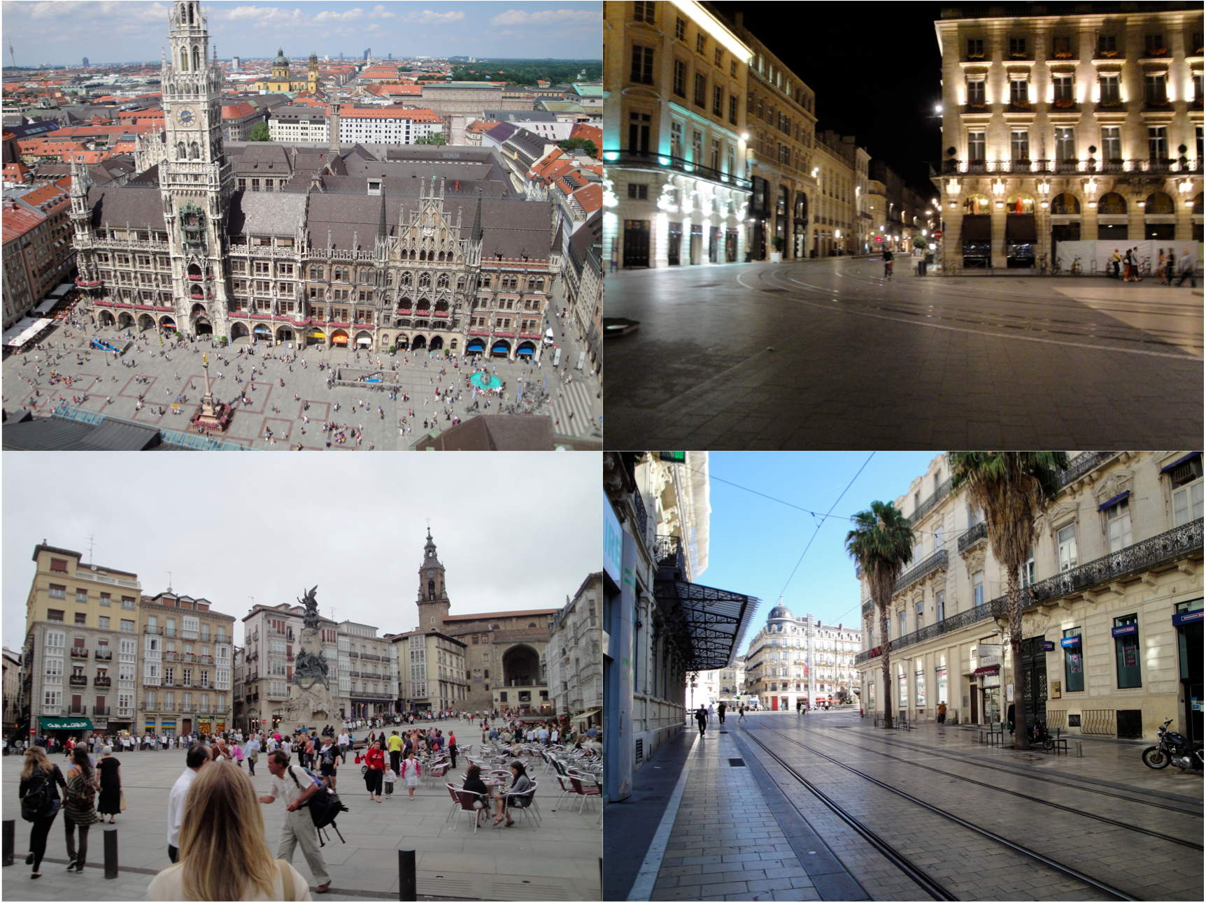Figure 2: Carfree city centers in Munich, Germany (top-left, Vitoria-Gasteiz, Spain (bottom-left), Bordeaux (top-right) and Montpellier (bottom-right), France. Streetcars traverse the carfree space of all four cities. Photos by the author.

The carfree models implemented in Europe demonstrate that rail transit is currently the best way to move people and goods within and between cities and towns. Rail offers the advantage of comfortable and highly automatable center-to-center transportation, as opposed to the point-to-point transportation enabled by cars and variations of paratransit (such as door-to-door shuttle service.) The accessibility of pedestrianized streets, modern streetcars and light rail (having floors at curb height), and heavy rail (subways and regional trains) also make rail the most appropriate for bringing comprehensive transit to the handicapped, except in cases where strict door-to-door service is required by specially suited vehicles. Rail fits well into the tight confines of existing right-of-ways--fitting within the width of one car lane--and its fixed guideway offers the safest and most predictable intrusion through public plazas and other carfree spaces. Rail also demands the financial commitment of a fixed guideway which prompts accompanying streetscape improvements and ensures its permanence to residents and businesses.

Figure 3: Bordeaux France. (Above) A mostly-pedestrianized plaza. Streetcars glide through the pedestrian area in a minimalistic and predictable path. Photos by the author. (Below) A street converted to host streetcars, one direction of traffic, and one parking lane, representing a significant step toward a fully carfree street.

Urban redevelopment that emphasizes carfree spaces with modern center-based rail transit would allow millions of people to live in reasonably sized dwellings within a ten minute’s walk of a stop or station in a rail network without the need for high-rises, as demonstrated in J.H. Crawford's reference model (Crawford 2009).

# Software and Literature Review

This literature review focuses on software-driven urban design that has attempted significant contributions to urban site redevelopments via public input or input otherwise coming from outside the internal planning process of a public or private entity. I found that no research exists on publicly-initiated carfree redevelopments that used 3D modeling software. Therefore, my review focuses on public action in promotion of any sort of streetscape redevelopment, such as calming traffic or introducing bike lanes and transit. Such actions may qualify as “participatory planning,” but the emphasis of the literature review and subsequent analysis of my own software is on the efficacy of software to instigate important site redevelopment ideas from the public, rather than the success of including the public in the planning process. I therefore prefer the term “significant external contribution” over “participatory planning.” Davidoff highlights the problematic tendency of the latter: “The difficulty with current citizen participation programs is that citizens are more often *reacting* to agency programs than proposing their concepts of appropriate goals and future action,” and he concludes that “there is something very shameful to our society in the necessity to have organized 'citizen participation'” (Davidoff 1965). Reactionary participation is particularly negative because it not only impacts those who are usually excluded from the process, but also “those who are typically involved, but who are drowned out by polar arguments and the influence of ‘experts’” (Brabham 2009).

I specifically include the word “significant” to suggest those persons who are self-motivated to contribute substantial plans, rather than those that are simply brought into the planning process in order to call it participatory. An important piece of significant contribution is in public instigation. Burby found that “when stakeholders take the initiative and put proposal on the table for consideration in plans, both the strength of plans and implementation success improve markedly” and in fact “stakeholder advocacy has the strongest impact of the various sources of policy initiative examined” (Burby 2003). Whether or not the process begins with public instigation, participants can contribute significantly to site redesign in a variety of ways, such as design, economic analysis, pedestrian usage patterns, and historical narrative.

The Internet-oriented catch phrase for public contribution is crowdsourcing, referring to the practice of solving problems or aggregating ideas and feedback from the public-at-large via the Internet. Virtually all tools use some aspect of crowdsourcing. One may consider significant external contributors as a subset of the participants of crowdsourcing software, since crowd sourcing participants often contribute very little or have minor interest in the subject at hand. Sites that ask users to rate rather than review a product, for instance, rely on crowdsourcing to collect data with minimum contribution from its users.

### Organized Participation with Software

A limited amount of experimental participatory planning has focused on a combination of user contribution and professional expertise to translate their ideas into a plan that can be visualized with software. This latter case permits the use of more sophisticated offline software, but the experiments cannot be classified as crowdsourcing, since they require a group to be assembled physically or virtually in coordination with those leading the project. Gordon and Manosevitch conducted such an experiment called Hub2, where a group of citizens in Boston, Massachusetts was assembled to deliberate over a new site plan in coordination with a designer who translated their ideas into 3D with a virtual world (Figure 4). The goal of their work was to study the possibilities of augmenting conventional deliberation by using a combination of social interaction and software (Gordon and Manosevitch 2011, 77). Augmented deliberation can produce or vet significant external contribution to urban redesigns. Rescape, for its part, can enhance this process by removing the requirement of a professional urban designer early in the process.

Figure 4: Augmented deliberation with hub2 (http://hub2.org/photos/IMG_2856.JPG)

Also in the realm of organized public participation, Bishop explored the use of 2D GIS maps and 3D visualizations--some of which were animated and some of which had multiple scenarios demonstrating economic, social, and environmental tradeoffs--to present development plans to the public (Figure 5). He found that the visualizations had the potential of engaging the public earlier in the planning process, granting a greater sense of ownership and instilling a better understanding of policy decisions that benefit the greater public good (Bishop 2005, 5,10).

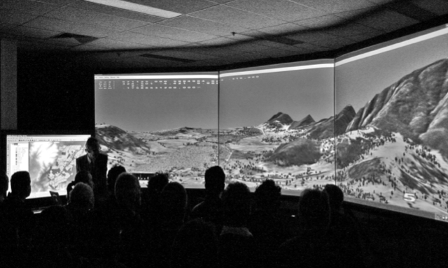Figure 5: Scenario Planning (Bishop, 2005, 5)

*Crowdsourcing Urban Planning and Publicly Accessible Design Software*

The use of software to garner urban planning contributions from the public has largely been limited to online websites that require no software installation, such that barriers to contribution are minimized. Table 1 on page 17 lists a large percentage ofEnglish-language sites that host online or downloadable software.

The most fundamental forms of crowdsourced urban planning contribution rely on text and 2D media-based reporting. Such web sites include By the City/For the City, which lets users suggest any type of urban space or system improvement to New York City (Institute for Urban Design 2011) (Figure 6). The suggestions are mapped and analyzed for trends, and some were entered into a design competition and visualized by urban designers for the Institute for Urban Design's Urban Design Week 2011. Other sites focus on reporting problems rather than making improvements, such as seeclickfix.com, which lets users flag urban infrastructure problems in any city and geo-reference them on a map (SeeClickFix 2011) (Figure 7). Problems may be posted with images and status updates, and in some cities and regions they are actively browsed by officials. The overarching purpose of suggestion and reporting sites are to enable citizens to cut through government bureaucracy and communicate directly with officials (Parcher 2010). Some commercial software suites that support citizen-government interaction have also emerged, such as Emerging Plans from Urban Interactive Studio (Urban Interactive Studio 2011).

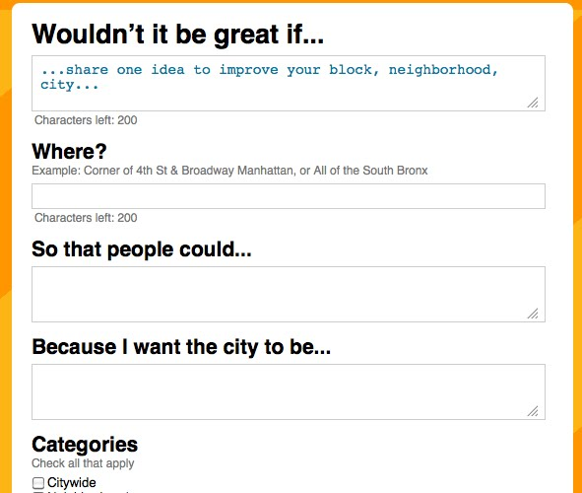Figure 6: Screenshot of By the City/For the City http://www.urbandesignweek.org/by-the-city/reports/submit (captured 2011-10-13)

The next level in terms of significant external contribution is represented in sites such as nextstopdesign.com, which is part of the research project “Crowdsourcing Public Participation in Transit Planning” by the University of Utah and the Utah Transit Authority, which took advantage of crowdsourcing to carry out a bus stop design competition and has now begun a transit hub redesign competition (Next Stop Design 2011) (Figure 8).

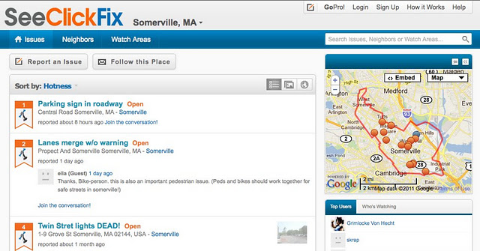Figure 7: Screenshot of seeclickfix.com http://seeclickfix.com/somerville_2 (captured 2011-10-13)

The project's purpose “is to use the Web to bring in new voices and different ideas to the public participation process for transit planning” and “shed light on the ways people participate in government decision making and design activities... [such that] ...similar projects can be undertaken to solve other public problems and needs.” (Next Stop Design 2011). Thus the project explores both how to foster public participation and how to use the Web to solicit good ideas from creative contributors. Brabham, the project lead of Next Stop Design, compares the advantages of crowdsourcing urban design to those of the remote collaboration on open-source software over traditional software development, postulating that “the crowdsourcing model may prove itself as a superior method for designing real spaces, planning the built environment” (Daren C. Brabham 2009, 243). He also highlights the advantage of non-expert ideas that are potentially inconceivable inside the planning profession, as well as the potential to harness “far-flung genius” (*ibid* 2009). Interestingly, the 2009 bus stop design competition drew large numbers of out-of-state and international entries (62.13% of submissions were from the United States,) confirming the potential for far-flung genius, but perhaps creating a “global-local tension” or a contradiction in goals for those using software to solicit local participation (D.C. Brabham, Sanchez, and Bartholomew 2010). The authors also warn of the emerging dominance of professional designs with 3D modeling tools as possible evidence that amateur designers were being deterred (*ibid*). Such a divide could arise between professional and amateur users of Rescape, but since Rescape is itself an extension to a 3D drawing program, it at least would not create a natural divide between professionals drawing in 3D and amateurs using 2D or physical media.

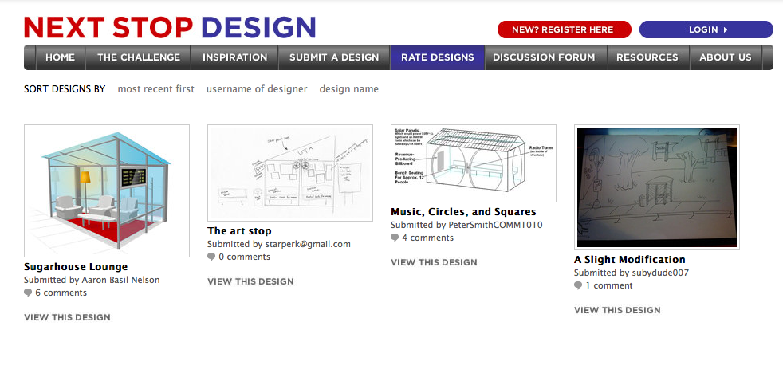Figure 8: Screenshot of nextstopdesign.com design rating page http://nextstopdesign.com/designs (captured 2011-10-13)

3D virtual world software has also emerged as a direct means to promote significant external contribution to urban design. Betaville is a standalone networked application that accesses a shared database of 3D models and meta-information about the models, such as the critiques of other uses (Figure 9). It allows users to explore a virtual world of redevelopment and green-field urban space projects in real places, such as New York City. The models, which are imported into the Betaville virtual world, derive from 3D modeling software ranging from the freely available Google Sketchup to professional products like Autodesk Maya (Brooklyn Experimental Media Center 2011). Betaville's creators make the following summary of Betaville's purpose:

Figure 9: Betaville screenshot demonstrating a redevelopment in New York City. Source: http://bxmc.poly.edu/sites/default/files/inline_images/MenuSketch0803.jpg

Anyone can propose changes to an online 3D model of a building, a district, or an entire city, in the form of a 3D model that can be "switched on" in the model, commented, and iteratively refined over time, outside the heavy costs and constraints associated with the formal design and planning processes now current. This environment can be shared by planners, designers, artists, and other experts, including those whose expertise consists in knowing what it's like to actually live in the places represented... By the time the formal planning and design processes are initiated, there is a readily accessible model and record of local conditions, desires, and the state of consensus (Skelton, Koplin, and Cipolla 2011, 355).

Betaville thus has a clear overlap in purpose with Rescape in its intent to harness creative ideas and local expertise to produce 3D models that redefine the planning process. The authors also ask the question of whether conditions have changed to a point “where fuller creative, critical, and technical participation in the means of development of new plans is practicable, and potentially effective?” (*ibid*, 356), which is essentially the same question this paper asks in regards to Rescape's ability to effectuate the planning of carfree spaces and comprehensive transit.

Betaville differs from Rescape in that it hosts models and tracks their evolution, whereas Rescape's purpose is to create models to be shared. The two are complimentary in that Rescape enhances Sketchup to help produce models for Betaville, which can in turn share them in the context of the rest of the modeled present-day city. Betaville is also comparable to Rescape in that its financial and ease-of-use barriers are minimized--both are open-source software and run on multiple operating systems.

Figure 10: Screenshot of opentripplanner.com http://opentripplanner.com (Captured 2011-10-13)

Other software projects that engender participation and collaboration with software include the Open Architecture Network, which is an online community that “brings building practitioners together with community leaders from around the world to collaborate on design and planning projects” in order to “improve upon the built environment” (Davis and Sigrist 2010, 43). Open Architecture maps the principles of open-source software to the planning context, especially those of collaboration and transparency. The nonprofit OpenPlans takes the concept of open-source planning quite literally, providing a wide range of open-source planning software to help governments run better by exchanging ideas and information with citizens and other governments (OpenPlans 2011). Among OpenPlans' projects are OpenTripPlanner and OpenGeo, open-source software projects that provide transportation mapping and geo-spacial data mapping, respectively (Figure 10). Both projects give users free access to valuable data that may be used in conjunction with neighborhood redesign. Similarly, OpenStreetMap is a user-contributed database of street and other geographic data that is freely available to assist users in unlimited applications, including redesign projects (OpenStreetMap 2011). Rescape itself relies on OpenStreetMap for all of its rendered way data.

Individual cities and regions have also made a mark in the world of crowdsourced planning. Bristol Rising is a web site intended to revitalize downtown Bristol, Connecticut using crowdsourcing that adheres to the Triple-Bottom-Line-Statement—social, economic, and environmental sustainability (Bristol Rising 2011) (Figure 11). The site hosts bold redevelopment plans that are deliberated over in forums, blogs, and events publicized online. One may expect to see the similar web sites emerge in cities and towns worldwide, especially given the availability of open-source and commercial software packages.

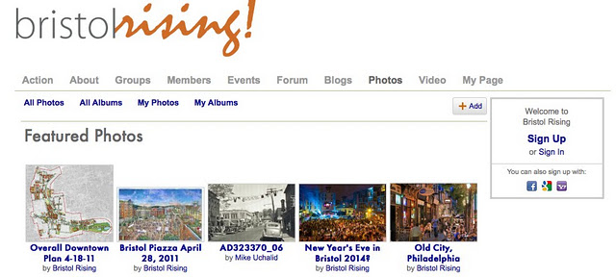Figure 11: Screenshot of bristolrising.com photo page http://bristolrising.com/photo (Captured 2011-10-13)

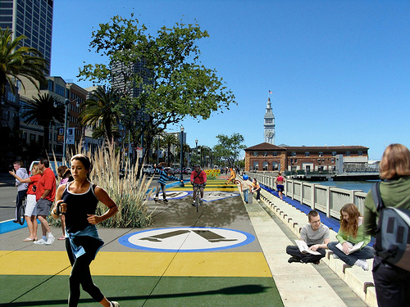Figure 12: AIA SF's Architecture and the City Festival Embarcadero redesign by Min Day http://farm3.static.flickr.com/2483/3970127866_b1d4f09421.jpg

Some urban redesign crowdsourcing is more targeted. In San Francisco, Good Magazine teamed up with SPUR (San Francisco Planning and Urban Research Association 2011) to delegate problem areas in the city to local designers (Fast Company 2011) . For instance, a busy portion the Embarcadero promenade was reimagined as a “slow space,” designed to slow traffic and increase greenery (Figure 10).

**Table 1: Software that enables public contribution to urban planning**

|  |  |  |  |  |  |
| --- | --- | --- | --- | --- | --- |
| **Software** | **Open Source?** | **Cost** | **Description** | **Standalone component for end users[1]?** | **URL** |
| Google Sketchup | No | Free Version and Pro Version (~$500) | 3D modeling software with Google Earth satellite image and building downloads. | Yes | http://sketchup.google.com/ |
| Google Earth | No | Free Version and Pro Version | 3D earth imagery with the ability to add 3D buildings and a wide variety of other features to aid in planning a site redesign. | Yes, as well as a web plugin. | http://www.google.com/earth/ |
| By the City/For the City | Yes | Free | Hosts ideas for improving a city with geo-spacial and text representations. | No | http://www.urbandesignweek.org/by-the-city/ |
| SeeClickFix | No | Free Version and Pro Version (Pricing is not listed) | Enables reporting infrastructure and other problems in a city. | No | seeclickfix.com/ |
| Betaville | Yes | Free | 3D city simulation that hosts collaborative and versioned (re)development ideas. | Yes | http://betaville.net/ |
| Modelur | Unknown | Pre-Beta release. Currently free for testing. | Like Rescape, extends Google Sketchup with a focus on building design. | Yes | http://www.modelur.com/home |
| Next Stop Design | Unknown | Free | Hosts contests to design or redesign urban infrastructure, an intersection, etc. | No (Google Sketchup is recommended to create designs.) | http:/www.nextstopdesign.com/ |
| Bristol Rising | Unknown | Free | Enables citizen engagement with government, public event announcements, and hosts redevelopment plans. | No | http://bristolrising.com/ |
| Esri CityEngine | No | Yes - Varies | 3D city modeling of existing and new sites. | Yes | http://www.esri.com/software/cityengine/ |
| Autodesk AutoCAD | No | > $1000 | 3D modeling software with accompanying products for animation, etc. | Yes | http://autodesk.com/ |
| **Geographic Data Software** |  |  |  |  |  |
| OpenTripPlanner | Yes | Free | Walking, bike, and transit trip planning. | No | http://opentripplanner.com/ |
| OpenStreetMap | Yes | Free | Hosts comprehensive street, path, rail, and other way data, building data, and virtually any other physical or natural infrastructure. | No | http://www.openstreetmap.org/ |
| OpenGeo | Yes | > $1000 | Hosts geo-spacial data and provides standalone and web client rendering of the data in 2D and 3D. | Yes | http://opengeo.org/ |
| Esri ArcGIS for Desktop | No | > $1000 | Hosts geo-spacial data and provides standalone and web client rendering of data in 2D and 3D. | Yes | http://www.esri.com/ |

### Impacts of public design contributions to redevelopment

As the public becomes armed with better access to information and visualization software, they will likely have a more substantial roll in the planning process, including instigation of projects and resistance to public and private development proposals that were previously difficult to oppose. Lindquist and Danahy document one such example in the Fort York Neighborhood of Toronto, where residents used visualizations of the site to initiate resistance to the building heights of new development that would dominate the view from the historic fort by using real-time visualizations of the site (Figure 13). They lost the particular battle but established a new precedent:

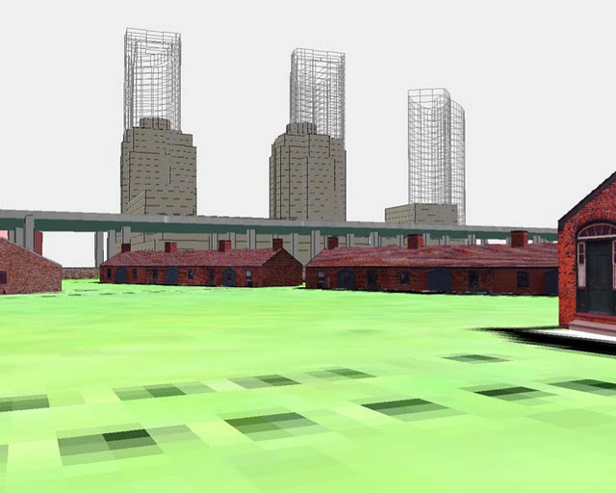Figure 13: Residents of the Fort York neighborhood used visualizations to counter high rise development. (Lindquist and Danahy, 2006)

The effectiveness of the tools clearly articulated the ramifications of the development to layperson and professional alike, necessitating the engagement of the professionals with the public on their terms. The application of this inversion of the traditional public participation model to any spatial planning project should make developers and officials take note; a willing public is now able to force engagement and negotiation using real-time immersive visualization. The success of these tools in completely altering the development process in Toronto is evidence of the communicative and democratic power the technology has to offer. Furthermore, including real time visualization early on in the design process as a communicative bridge between the public and professionals can only benefit all parties by avoiding costly trials and wasted time, positively affecting the developer’s bottom line...The major impact was that all future planning for this area of the City is evaluated using real-time immersive visualization at the CLR [University of Toronto's Centre for Landscape Research] when the citizens ask for it. (Lindquist and Danahy 2006)

Lindquist and Danahy allude to a future in which public and private planning projects will incorporate iterations of public vetting via immersive visualizations. The boundaries of who initiates redevelopment projects of public space may likewise be blurred as the public gains the tools and social media capabilities to quickly visualize and modify any public (or private) space virtually and then publicize it.

A recent comprehensive business plan by a Stanford University undergraduate student to build a streetcar in Oakland, California has drawn substantial attention from the media and the city council. Daniel Jacobson studied the recent streetcar projects in Portland, Oregon and Seattle, Washington in order to formulate a comprehensive proposal for a trunk streetcar line in downtown Oakland (Jacobson 2010). He superimposed images of the streetcars and tracks upon street photos of the proposed route, which complimented traditional land use maps and photos from the existing lines in Portland and Seattle (Figure 14). Jacobson's comprehensive economic analysis was the real selling point of the proposal, but the graphics were essential to captivating his audience. Though Jacobson's work is exceptional, it serves as a good template for members of the public who craft urban redevelopment proposals and wish to support their plans with written analysis.

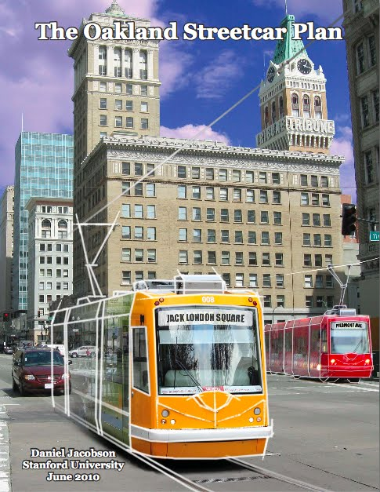Figure 14: The cover page of Daniel Jacobson's Oakland Streetcar Plan with streetcars overlaid on the streets of Oakland (Jacobson 2010)

### Review of carfree urban space literature

The most extensive writings on carfree urban design are J.H. Crawford's Carfee Cities and Carfree Design Manual and Richard Register's Ecocities and Ecocity Berkeley (Figure 15). Crawford's works advocate the design of new carfree cities based on a reference model that incorporates some of the best practices of Medieval city design as well as some of the design patterns proposed by Christoper Alexander et al. in their seminal work Design Patterns (which did not advocate carfree cities.) (Crawford 2002), (Crawford 2009), (Alexander, Ishikawa, and Silverstein 1977). Some such principles are the use of courtyards to provide intimate public space for the abutting homes that form an urban village, and the use of narrow streets and four-story building limits to promote a dense but human scale. Register takes a far more ecologically-oriented approach, arguing for large buildings of high density that integrate into the natural environment to enforce harmonious and sustainable communities. (Register 2006), (Register 1987) Though each author focuses largely on green or brown field development (new sites or formal industrial sites, respectively), rather than neighborhood redevelopment, many of their principles are quantitative in nature and therefore applicable to the urban redesign aims of Rescape.

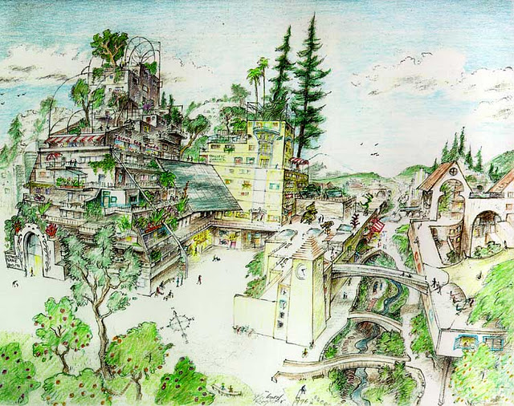Figure 15: An ecocity sketch by Richard Register (Register 2006)

Figure 16: Carfree city districts—part of the Crawford's Reference Topology from Carfree Cities and the Carfree Design Manual. http://carfree.com/draw/lobe97_big.gif

For advocates of carfree cities like Crawford and Register, comprehensive transit is an essential part of the design paradigm, even as increased densities and more holistic urban form allow for a far higher percentage of trips on foot. Crawford advocates the use of light-rail and metro between the hubs of his reference model (Figure 16). Register also advocates rail as the regional transportation solution that can be integrated with the natural environment with the least impact (Register 2006, 21). Both authors also propose rail use to enable freight movement without the use of trucks, and Crawford explores the concept of metro-freight—delivering freight to carfree cities by subway or light-rail, combined with power-assisted devices to help delivery persons with the “last-mile” of delivery (Crawford 2009, chap. FREIGHT). Paris, France is currently exploring the use of their new tramway network for freight to reduce truck use (Freemark 2011)

# A Description of Rescape's Functionality

As a graduate student of urban planning, I found 3D site designs with Google Sketchup extremely useful for various course projects, and the software is widely used by students and professionals of urban planning, urban design, landscape architecture, and traditional architecture. Additionally, Sketchup provides an intuitive user interface that does not require the expertise or high cost of traditional 3D modeling programs such as AutoCAD or urban design software like City Engine (Autodesk 2011), (Procedural 2011).

Sketchup supports fundamental 3D operations with relative ease; users may draw a 2D shape with a line tool and extrude the surface to make the shape 3D. Pre-built 3D components are simple to download into the model via the Sketchup 3D Warehouse, which offers thousands of user-created components for free via a web browser interface. Sketchup also has built-in support for Google Earth satellite images, allowing users to download an image of their choice that is then centered around Sketchup’s 3D coordinate axes. Sketchup records the geographical coordinates of the satellite image in order to enable other satellite images to download relative to the first, as well as to allow geo-positioned 3D buildings to download from Google Earth to an accurate placement atop the satellite image. Rescape is designed to be both a tool and an instructor. It begins with an interactive tutorial that guides the user through a sample process of performing a site redesign (Figure 17). After the tutorial, the user may choose their site of interest and use the tools that were demonstrated by the tutorial. The tools themselves provide further guidance by helping the user adhere to design realities, such as minimum widths and curve tolerances. Finally, since the software is built upon Google Sketchup, it is possible to guide the user without limiting them.

Figure 17: The Rescape tutorial. The special Sketchup model on the left has page tabs that correspond with the pages of the guide on the right. The guide has interactively fills out the Sketchup model while teaching the user how to use all of the Rescape tools.

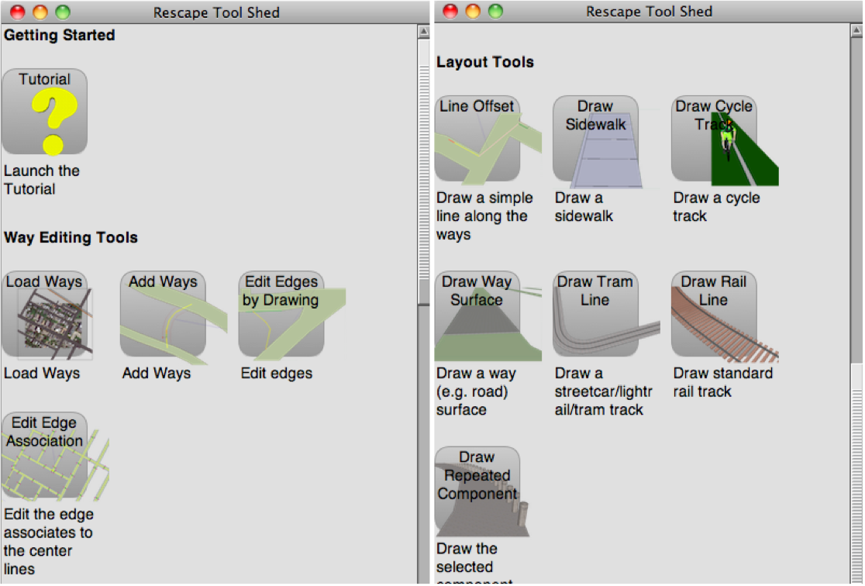Figure 18: The Rescape tool shed provides tool selection and descriptions.

The following sections parallel the pages of the Rescape tutorial and describe the sequence of steps for creating a site redesign in Rescape.

### Downloading Ways

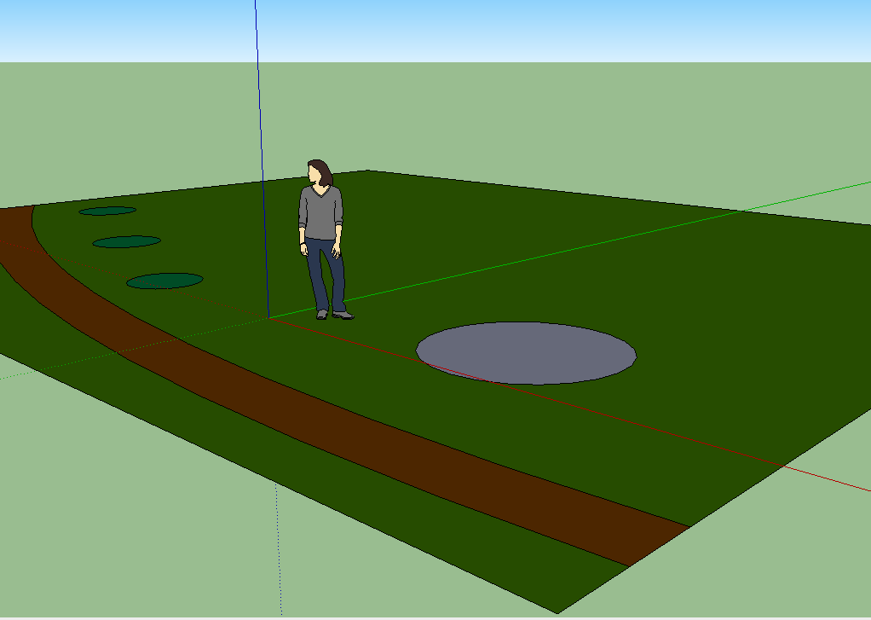Figure 19: A basic flatwork base map in Sketchup.

Sketchup provides a useful drawing canvas for site specific urban design on the satellite images. Lacking in Sketchup, though, are tools and data for rendering building footprints, roads, paths, railroads, and waterways, which would be useful to have demarcated when doing a site redesign. One effective technique for urban design in Sketchup is to create a “flatwork base design” that conforms to the varying surfaces (Tal 2009). This is a simple 2D surface where each surface type is defined by line segments to form a filled shape (Figure 19). For example, a park might have a green surface for the grass, a grey circle in the middle representing a fountain, and various brown paths representing walking paths (Figure 19). These surfaces may in turn be extruded upward to create the 3D object they represent. The fountain base circle, for example, might be pulled up into a cylinder and then sculpted with other tools to create the 3D fountain (Figure 20).

Rescape fills a void in Sketchup by allowing the user to download way data from OpenStreetMap. The software parses the OpenStreetMap data and draws 2D surfaces representing any type of way. If the way data includes a width, Rescape draws a path with the given width, and otherwise defaults to preconfigured values (Figure 21). Neighborhood roads for instance, might default to 50 feet, while major arterials might default to something wider (more sophisticated defaults are needed for internationalization.) Rescape downloads ways only for the area represented by the satellite images that the user has downloaded. It creates a continuous surface for each way type but does not attempt to join discrete way types, such as walking paths and roads, into a single surface. This is partially due to the potential overlap of road and path data, complicating the proper merger of paths into on single 2D surface.

Figure 20: The flatwork base map developed with 3D components, textures, and extrusions.

Once downloaded and rendered, the surfaces are more sophisticated than simple Sketchup lines and faces. Data is embedded into the surface that represents the network of way center lines connected at intersections, from which Rescape can create a computational graph to calculate the shortest path from one way to any other. Furthermore, the edges of the surface are each associated with the center line segment whose boundaries they represent, and any point on the way surface can be quickly resolved to the closest center line segment or edge to assist in the accurate layout of streetscape components. Rescape maintains full knowledge of these networks even as the user edits them and inserts new ways.

Figure 21: The complex network of street, path, metro, and waterways rendered by Rescape for the center of Paris. Default widths are too narrow for the Seine River, but the user can use Rescape tools to widen them, or remove them if they are unimportant to the redesign.

There are cases where OpenStreetMap does not have data for the area requested--though this is relatively rare--or there are omissions in the data. OpenStreetMap does allow users to contribute way data. The tools described next allow users to create compatible way networks by tracing center lines of roads, paths, etc. on the downloaded satellite images.

### Modifying Ways

In order to maximize positive change, users are permitted by Rescape to add, modify, and remove ways. To add a new way, the user simply selects an illuminated center line and draws connected line segments, forming a dead end or connecting to another way. The user can even use Sketchup's line drawing tools, such as the arc tool, to create a line and then turn it into a new way. Once the user has drawn the way, they are permitted to “offset” the way, meaning define the width of the way by dragging their cursor or typing in a value (Figure 22).

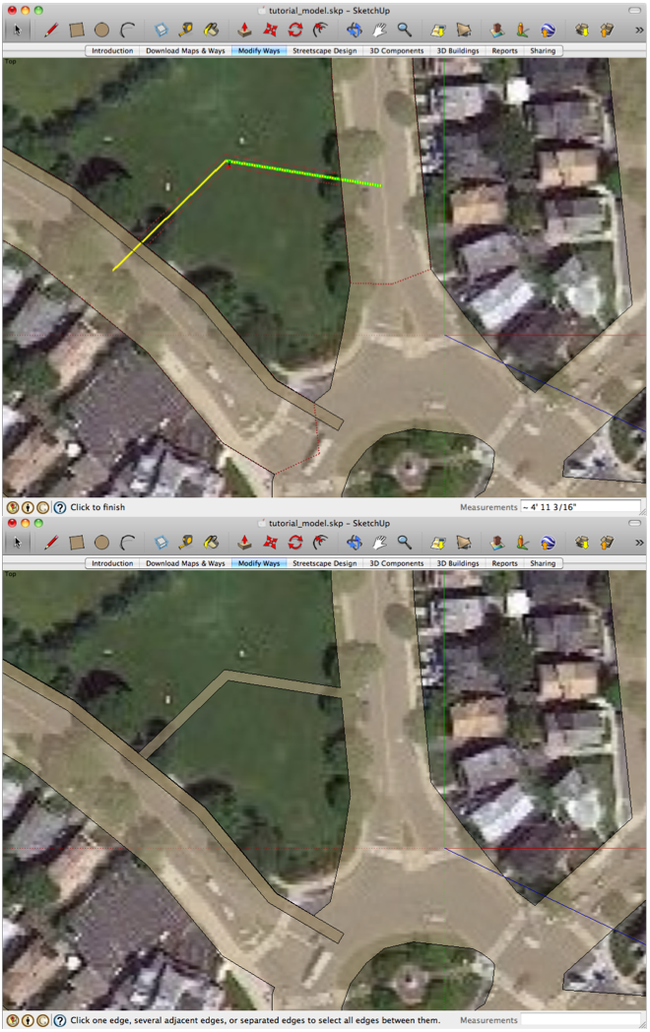Figure 22: (Above) Adding a way requires drawing a line (yellow) and then offsetting its width (red outline). (Below) A completed new way.

Deleting or modifying a way is even easier. To delete, the user simply traces the illuminated center lines of the ways they wish to remove. To modify, the user can drag any illuminated center line point to a new location, provided edges of the surface do not intersect those of another way.

The edges of surfaces may also be modified in order to make the surface more accurate to the real-life way, or perhaps to create new space for pedestrian or transit activity. The user selects a point along an edge and draws line segments representing the new edge until reconnected at another point on an edge (Figure 23). The drawn line segments may either widen or narrow the surface. Rescape associates the new edge segments to the way segments of the old edges.

Figure 23: (Left) Creating a new edge by drawing a path from one edge toward another with a point in between. (Right) Completing the edge by double-clicking the second edge modifies the surface accordingly.

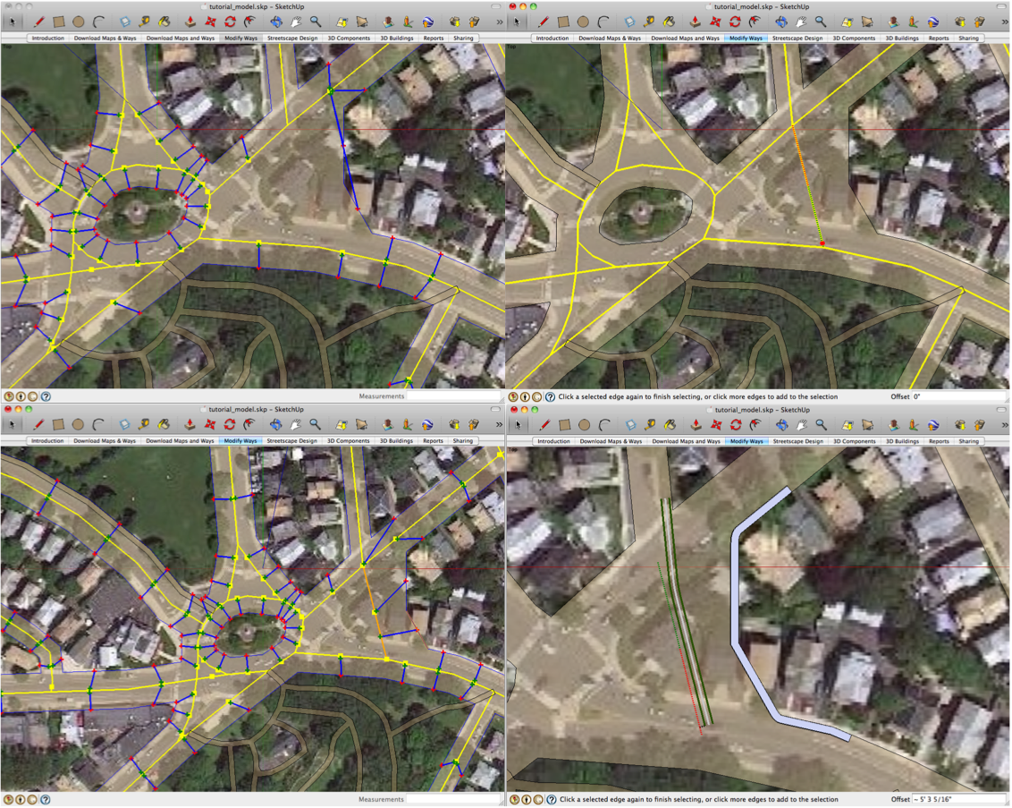Figure 24: (Top-Left) Use of the Edge Association tool after creating a new plaza area shows the edges associated by blue lines to the closest center lines (yellow). (Top-Right) A new way is created using the Add Way tool. (Bottom-Left) The Edge Association tool is used to associated closest edges to the new way. (Bottom-Right) The new way to draw a cycle track and the new edges host a sidewalk.

The user may also use a combination of the Modify Edge and Add Way tools to add a way through a plaza. The multiple steps are demonstrated in Figure 24. The user creates the plaza area by drawing a new edge, and then draws a new way through the plaza. The final step is to use the Edge Associator tool (Figure 24 bottom-left) to associate the new edges to the new way. By creating the a way through the plaza the user is able to align streetscape components, such as a sidewalk and cycletrack to the new way or edges (Figure 24 bottom-right).

### Streetscape Design

Perhaps the most prominent feature of Rescape is its various tools for laying 3D components on the ways and alongside them. Rescape permits users to lay 3D streetscape elements that are continuous or repeating along a way. Elements such as streetcar tracks, sidewalks, road markings, trees, and generic buildings are all easy to lay along any way relative to an edge, the center line, or both. Some elements, such as buildings, are configured to be placed to the side of the way. Some elements need only follow the way partially and then divert across the map, such as a streetcar track. Figure 25 shows two configurations for streetcar tracks. Others, such as sidewalks, are always confined to the edge of the way. Rescape even lets users lay arbitrary

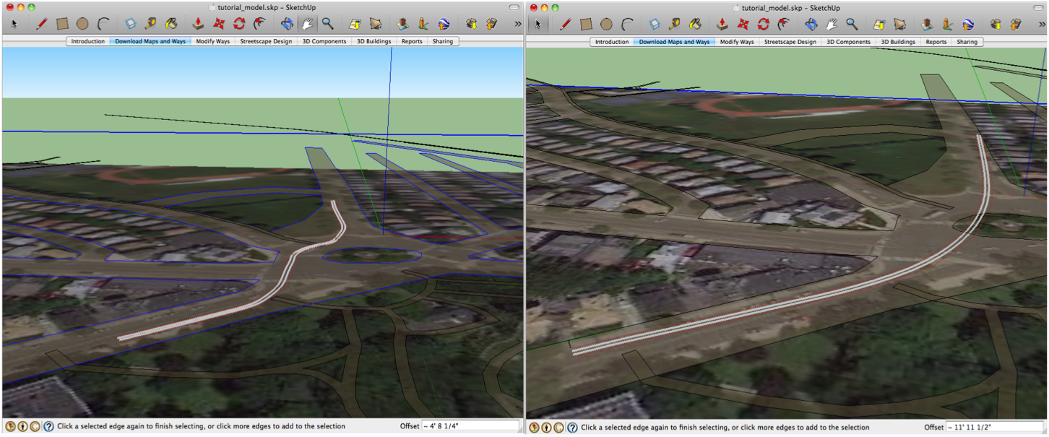Figure 25: Drawing a streetcar track aligned to the roadway. (Left) The user only clicks the start and end points to make this path. The middle of the path automatically contours to the roadway. (Right) Drawing a streetcar track that partially ignores roadway. The user clicks the start, a middle point in the rotary with a modifier key depressed (to make rescape draw a direct path), and then the end point to again follow the way to make this path.

components along path, such as a tree from the 3D Warehouse. Users download and select the lamp post, draw a path of their choosing, and then move the cursor or enter a value to determine the spacing of the lamp posts (Figure 26).

The streetscape layout tools have several options that can be toggled by holding modifier keys, such as the shift or command keys. For instance, the default behavior of drawing paths is to associate the path with the nearest edge or center line segment, but holding the shift key locks the offset to a certain edge or center line segment, rather than switching to the nearest one. For streetscape elements that can either follow or diverge from the way, the command key allows the user to draw a path directly from one way to another, without following the shortest path along the ways. The combination of command and shift keys smooth the path along the way from one chosen point to another when the path changes from one edge to another or the center line, rather than the default of keeping the path parallel to its associated edge or center line segment. The user also has the option of typing in a numerical value to set the precise offset of each path segment from its associated edge or center line segment, or they can use the arrow keys to “nudge” the path segment one foot at a time in either direction.

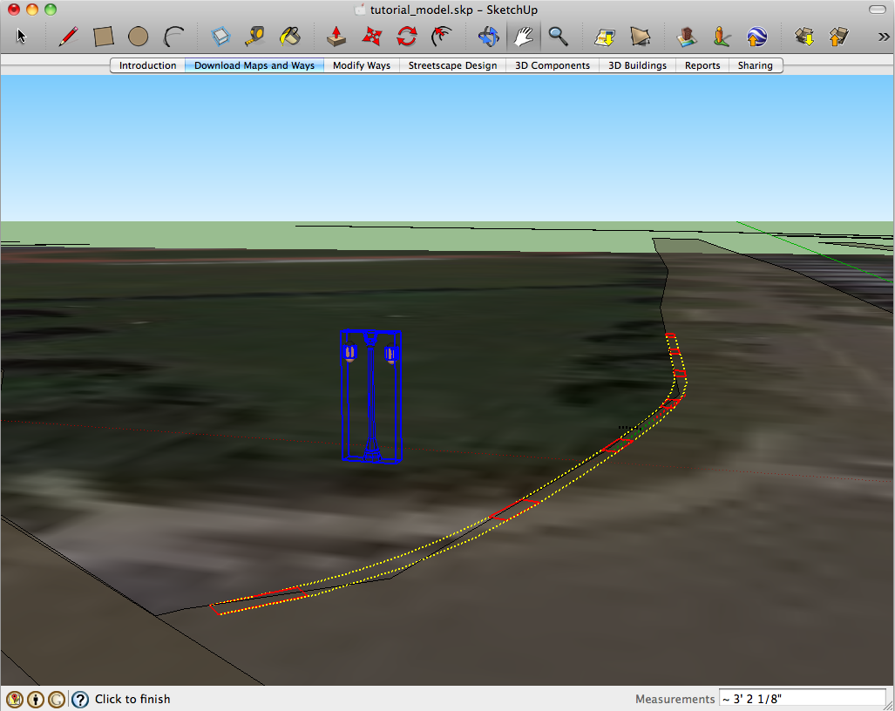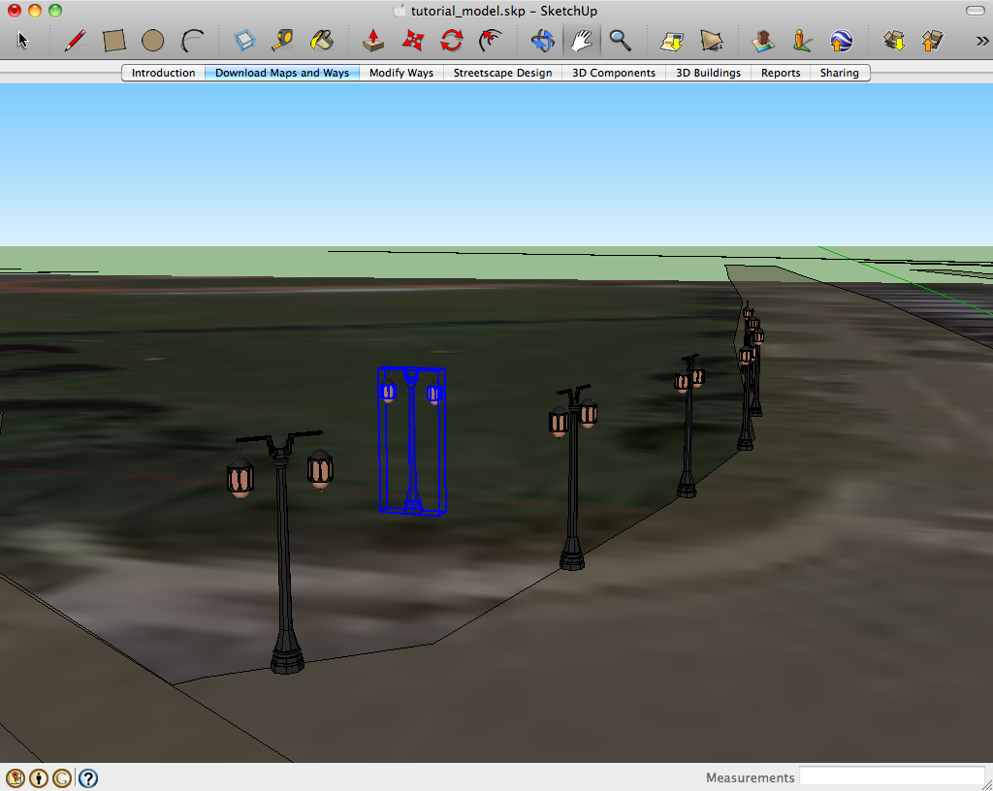Figure 26: (Above) With a street lamp 3D component select, the users draws a path and sets the spacing. (Below) The finalized path of street lamps.

Once the user has finalized their selected path by double-clicking, Rescape renders the 3D component along the path. The component may be continuous, as in the case of tracks, or repeating, as in the case of street lights. At this time it is not possible to edit the rendered component's path, but this feature could certainly be added in the future, as could the ability to fuse continuous components such as tracks that fork. It should also be possible to duplicate a path, such as a streetcar track, so that a parallel track and laid alongside it and correctly account for curvature.

Sometimes users will wish to use Rescape's path drawing capabilities for lines or surfaces that are not ways. For instance, a user may wish to draw trees along the boundary of a park where no road or path exists. In this case, the user can instruct Rescape to follow a certain set of edges selected prior to the streetscape layout tool.

### Additional 3D Components and Streetscape Decoration

The streetscape layout tools go a long way toward creating a complete streetscape, but many other components that do not repeat along a path are needed to draw a realistic 3D scene. Pedestrians, street signs, and fountains, are a few of thousands of possibilities. It is also necessary to color and texture surfaces to make them more realistic looking. A pedestrian street, for example, might be textured to give the appearance of paving stones, and cycle track might be blue painted asphalt or hard-packed sand instead of the default color that Rescape uses. These abilities are all native to Sketchup, and require no extra tools from Rescape.Sketchup enables manual distribution and decoration of components, and there are other free and inexpensive Sketchup plugins to help with random distribution and random scaling of components to make them more realistic. For example, *Scale and Rotate Multiple* is a downloadable plugin that randomizes the scale and rotation of objects like trees, to make instances of the same component distinct (SketchUcation 2011).

Since the ways drawn on the satellite images represent only drawing guides, Rescape provides tools to define additional surfaces. The user may wish to draw a surface adjacent to the existing ways to represent public spaces such as a park that takes up an entire block. Rescape provides a Surface Creator tool to create a new surface based on an area partially or fully enclosed by ways. The user selects the surface tool and simply clicks on an edge of the way to create a new surface in an enclosed area, or selects edges and free points to create a partially enclosed surface (Figure 27). If the uses requires a 3D surface atop a way to complement other 3D components, such as streetcar tracks, they can use the Way Surface Creator tool to draw a surface along any way (Figure 28).

Figure 27: Surfaces can be defined based on the ways. (Above) The surface create tool automatically detects a closed area and fills it. (Below) An open area is defined by the user and the ways and filled.

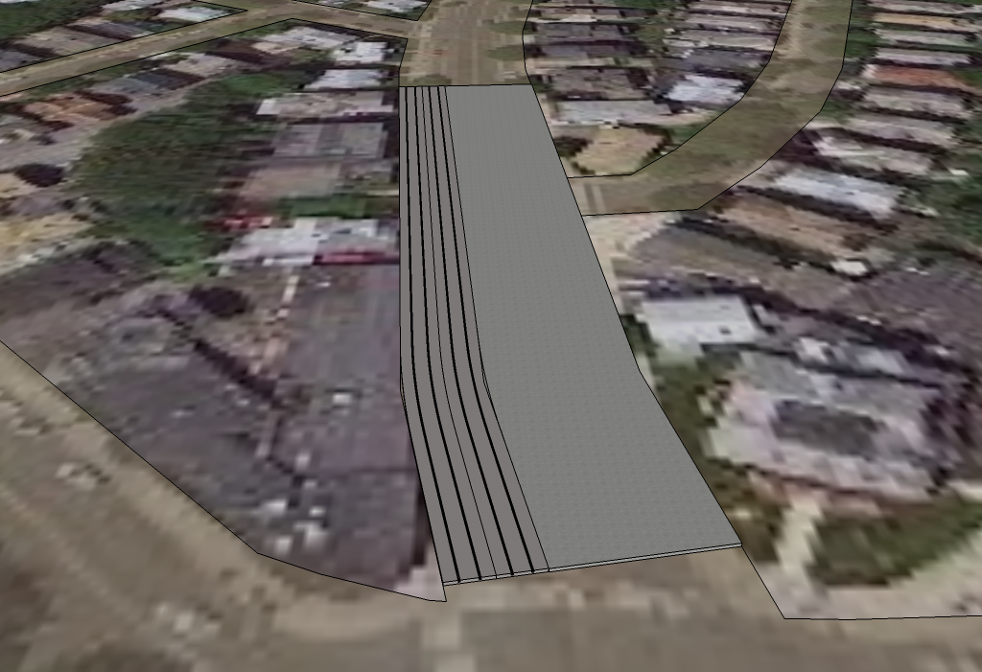Figure 28: A surface placed along a road to compliment streetcar tracks. The Way Surface Creator tools allows the user to define a path and then stretch it to the desired width.

### 3D Buildings

Since Rescape is streetscape oriented, it provides no special support for drawing buildings, other than the streetscape layout tools that allow users to layout copies of a generic building. Sketchup provides several options for placing buildings in site models (Figure 29). The first option is to download any buildings that have already been created in Google Earth. Many famous buildings and monuments, as well as individual businesses and homes, have been modeled in Google Earth. Sketchup allows you to download these buildings and it will place them accurately in your model. Google Earth also has a building trace tool, called Building Maker, which is currently only enabled in certain urban regions of the world. It allows users to match a 3D wireframe up with the building from various 2D photo angles to create the shape of the building. This tool is currently cumbersome but ought to be improved in the future. When all else fails, the simplest thing to do is to trace the footprint of a building on the satellite image using the Sketchup line tool. Once a 2D surface is formed the user can extrude the surface upward and modify the 3D component to “sculpt” it into a shape of the building.

Figure 29: A variety of buildings in Sketchup. The grey building were created by the public in Google Earth's Building Maker and the colored buildings were created by hand to represent infill development and an outdoor market. Model created by the author prior to Rescape.

There are many instances when the user should add new buildings or modify existing ones, especially in cases where they wish to densify buildings in a business center or at a transit station. Unless users have significant experience in architecture or urban design, it is often best to simple place identical generic buildings, or simple building with minor variations, without giving detail to the buildings. Making choices about the buildings' texture, windows, etc. may place more emphasis on the style of the buildings than is intended. Rescape's primary purpose is streetscape design, but there is nothing to prevent users from fully designing the exterior of buildings and downloading other Sketchup plugins to aid building design.

# Next steps planned for the software

The following sections address general shortcomings of the software as well as those specific to each of general features described above.

### Elevation changes and overpasses

The biggest shortcoming in Rescape is its inability to handle elevation changes. To decrease the complexity of the software, Rescape treats all way surfaces as flat. It does have the ability to interpret a layer attribute in the OpenStreetMap data in order to handle overpasses in a primitive manner. Rescape simply draws a disconnected surface that is at another level than the normal surfaces. Rescape does not currently render slopes, though this would be ideal to handle overpasses and the natural elevation changes in the terrain. Sketchup has innate abilities to handle elevation, including contour data that accompanies satellite image downloads, such that the satellite may optionally be displayed as a contoured surface. Sketchup has a suite of tools called the Sandbox Tools for handling curved surfaces, including ones that allows the user to drape flat surfaces and 3D models onto a sloped surface. Rescape could use this feature to create elevation in a site model, or at least demonstrate to the user how to do so. However, it would not solve the problem of artificially elevated ways, such as overpasses, ramps, and bridges. Alternatively Rescape could draw all surfaces with elevation levels by sloping all paths and surfaces. Such functionality would certainly not be impossible, and Sketchup is already designed to interpret the X,Y, and Z coordinate of the user's cursor based on inference. Rendering sloped surfaces in Sketchup is difficult, because every sloped surface is actually a composed of many 2D triangles. The combined triangle surfaces form the curved slope, and the inner edges of the triangles are hidden to create the curved surface effect. There are plugins that assist with rendering curved surfaces, so Rescape may be able to use a combination of borrowed plugins and custom code to accomplish the task.

### Improvements to Downloading Ways

Downloading ways from OpenStreetMap is extremely convenient and utilizes the most comprehensive free source of way data available. That said, there are instances where the data is either incorrect or structured in such a way so as to create errors in the Rescape rendering. One prominent case is that of divided boulevards where each direction is erroneously tagged with the full width of the boulevard. This causes Rescape to draw overlapping surfaces for each direction of the boulevard, which ruins the contiguous outline of the way surface and causes an incorrect rendering. Such problems must be handled with complicated code that corrects the data before it is rendered. As Rescape is improved, it will handle more error cases and “corner cases” in the OpenStreetMap data, the latter being cases where the data is correct but the situation is unusual.

### Improvements to Modifying Ways

There are many potential improvements for the way and edge modification tools that would make them more effective. One current problem is that ways can not be extended at their ends, but must be extended from the sides. There is also a need for code that does a better job of maintaining the integrity of the way surfaces, which can easily be ruined by manual edits by the user.

### Improvements to Streetscape Design

There are myriad features to add to the streetscape layout tools. One would be the ability to configure particular tools to override the default properties that are now configured programmatically. For instance, streetcar tracks are configured to create a curve at a minimum radius, but this could be made configurable to allow tighter curves where appropriate. The texturing of the components could also be configurable. Railroad ties could default to a cement or wood texture and color. Streetscape layouts could have the option of laying multiple components in parallel, such as two streetcar tracks to accommodate both directions. The path of rendered components could also be made editable, such that the user might drag the point between two line segments to reposition the path and the have it re-render without forgetting any texturing that the user applied. In the same vein rendered components could be expandable at the ends, be able to spur off down new paths, and be able to merge at intersections with matching component types.

A phenomenal addition would be a design tool so that users could create streetscape layout templates. Many of the existing streetscape layout tools work with custom code that loads or draws a cross section image, such as a railroad rail, and then uses Sketchup's *Follow Me* tool to extrude the 2D cross section surface along the user's chosen path. If users were given a design tool, they could configure the rendering of new components that need to be extruded to follow a path or need both extrusion and some repetition, as is the case of the railroad track's rails and ties, respectively. The design tool combined with the configuration interface described previously would give the users unlimited streetscape layout tools.

Preconfigured templates would jump-start the process of building a model. Some uses might wish to start with having the streets contain traditional sidewalk and asphalt layout and then make changes, rather than starting with unsurfaced roads. Other templates might automatically place streetcar tracks or bus lanes down any major street, or line all streets with trees.

At a higher level, streetscape components could calculate complex information about their cost based on their length or frequency in order to help a user do an economic assessment of their redesign. However, calculating capital costs must be accompanied by a calculation of economic, environment, and social costs and benefits, which would be the job of sophisticated urban design software, not Rescape. Other high-level functionality such as the aforementioned transportation and pedestrian-flow modeling are similarly far outside of Rescape's scope.

The streetscape layout tools could also be made to run more efficiently so that the path drawn by the user responded to their cursor movement without the delays that currently experienced. One major efficiency hurdle is Sketcup's inability to run simultaneous processes, which practically prohibits background calculations that could be made ahead of time without freezing the user interface. Sketchup is able to run external commands and use the data that the externally running programs compute, so it might be possible to offload some of the processing outside of Sketchup to improve performance.

### Adding Report Templates

A report creation tool would add significant new value to Rescape. Sketchup already has interesting options for exporting 2D images of a model. It has shadow configuration based on the time of day and year, and camera configuration options to allow export of the model from any viewpoint and zoom level. An effective report tool would instruct the user on how to take screen shots and export these screenshots to a report template. The report template would guide the user through several topics in describing their design plan, as well as supply web resources and examples of other projects as guidance.

### Sharing

Sharing the model or report online is the ultimate goal of Rescape. There is a noticeable lack of publicly generated urban redesign projects, as evident in the literature review, especially in the domain of carfree spaces with comprehensive transit. Having a location-searchable web site where models and reports could be shared would likely have a significant impact on the carfree cities movement, especially if it became a well-used reference for transit, biking, and pedestrian advocates. The site would ideally become a primary source of car-free redevelopment ideas, hosting discussions about particular sites and even sponsoring competitions to redesign a certain place, in the spirit of the Next Stop Design website described below (Next Stop Design 2011). Campaign sub-sites, such as “The Charles River Carfree Challenge. Boston vs. Cambridge. Who will pedestrianize their riverfront first?” would be a popular way to solicit redesign ideas and media attention.

The long-term goal of Rescape is to create a web site for sharing neighborhood redevelopment proposals that for carfree or car-light areas with comprehensive transit. While this is yet to be implemented, there are other web sites and software products that could host site designs or user-written reports that contain screen shots.

# Implications for urban planning

What urban planning lacks (and that from which other fields profit) is easy access to the creativity and occasional brilliance of outside contributors. In contrast to software development, in which independent individuals have often changed the field and sometimes even altered society, planning is rife with barriers that block meaningful contribution from the citizens who may possess the brightest ideas. Worse still is that protective barriers fail to block poorly designed or even detrimental plans that are generated by governments and businesses who simply know how to operate within the system. As evident in a recent highway proposal to access a sensitive coastal area in San Diego, California, and the Keystone XL Pipeline proposal that would enable catastrophic greenhouse gas emissions from the oil sands in Alberta, Canada and risk spills in sensitive areas, the harm of highways and fossil fuel usage have still not been accounted for by environmental regulations and must be continually resisted by the public (Rodgers 2008), (Natural Resources Defense Council 2011).

The traditional methods of streetscape improvement in North America make it difficult to accommodate the large-scale transformation is necessitated by climate change and diminishing resources. The North American political process is geared toward incremental improvement, if any at all, because so many entrenched interests and laws stand in the way of change. Such barriers are the nature of government, and in many cases protect the population. In the case of streetscape allocation, though, the public interest has been neglected by a century of motorization because interest was only considered in terms of automobile throughput (Swope 2005, 3). In contrast to common politically bottlenecked improvements to urban space, there is evidence that major disruptions to car use have had unpredictably positive results. Cases of sudden elevated freeway removal in the United States in San Francisco and New York City (caused by structural damage) have had positive social and economic benefits, as have major politically motivated pedestrianization, bus rapid transit, and *Ciclovía* (regularly closing streets for bikes and pedestrians) projects in Curitiba, Brazil and Bogota, Columbia. All exhibit large-scale non-incremental changes that improved the urban form without worsening traffic or the economy. (Congress for the New Urbanism 2011), (Kruse 1998), (Preservation Institute 2011), (Wright 2001), (Rabinovitch 1996, 60).

Rescape encourages disruptive changes to public space and right-of-way by giving users a blank slate to re-design the streets of concern and interest to them. It does not approach street modification from the currently popular traffic-calming approach, but instead asks users of the software to disregard in part the needs of private motorized vehicles. Most users will in time consider the needs of private vehicles, but that should come after adequate space for pedestrians and their urban activities are allocated, including the ability to travel with a bike and transit, and after the movement of commercial and personal freight is accommodated.

Until abundant precedent of carfree spaces exist in North America, politicians will continue to concern themselves primarily with the quantitative impact of a pedestrianization project to automobile throughput and parking—which are difficult concerns for advocates to assuage—rather than the qualitative and carfree transportation improvements that both make car access less relevant. Even without access to the quantitative evaluation that politicians demand, individuals should have the power to promote good projects and block bad ones using qualitative tools. Providing free urban design software is one of the best potential mediums to promote positive change toward truly sustainable and more livable human settlements. Visualizing change in 3D is powerful; it should be simple enough for a layperson to create a 3D walk-through yet realistic enough to allow an audience to recognize the re-imagined space and feel immersed in the simulation. In time, the software could be enhanced with transportation and pedestrian flow modeling tools as well as quantitative tools that measure the full cost accounting (economic, ecological, and social) of the redesign. Such a complete urban planning software package is likely develop in the near-term as a commercial product for professionals. It is essential that open-source software developers contribute to a freely available software package to empower the public. Rescape provides a good example of simple yet compelling streetscape modeling. A permanent solution will need to shift its dependency from Google Sketchup to an open-source 3D modeling application. Rescape could be ported as a plugin to one of the currently available open-source 3D modeling platforms, or its features might inspire new standalone software that incorporates an open-source 3D engine, much like Betaville and many 3D games employ.

# References

Alexander, Christopher, Sara Ishikawa, and Murray Silverstein. 1977. *A pattern language: towns, buildings, construction*. Oxford University Press US.

Autodesk. Buy AutoCAD 2012 - Autodesk. http://usa.autodesk.com/autocad/how-to-buy/.

Bishop, I.D. 2005. “Visualization for participation: the advantages of realtime.” *Trends in real-time landscape visualization and participation. Wichmann, Heidelberg*: 2–15.

Brabham, D.C., T.W. Sanchez, and K. Bartholomew. 2010. Crowdsourcing Public Participation in Transit Planning: Preliminary Results from Next Stop Design Case. In *Transportation Research Board 89th Annual Meeting*.

Brabham, Daren C. 2009. “Crowdsourcing the Public Participation Process for Planning Projects.” *Planning Theory* 8 (3): 242 -262. doi:10.1177/1473095209104824.

Bristol Rising. About Bristol Rising - Bristol Rising. <http://bristolrising.com/page/about-bristol-rising>.

Brooklyn Experimental Media Center. Betaville | BxmC. http://bxmc.poly.edu/betaville.

Congress for the New Urbanism. Charter of the New Urbanism | Congress for the New Urbanism. <http://www.cnu.org/charter>.

Burby, Raymond J. 2003. “Making Plans that Matter: Citizen Involvement and Government Action.” *Journal of the American Planning Association* 69 (March 31): 33-49. doi:10.1080/01944360308976292.

Crawford, J. H. 2002. *Carfree cities*. International Books, November 1.

———. 2009. *Carfree Design Manual*. International Books, April 1.

Davidoff, P. 1965. “Advocacy and pluralism in planning.” *Journal of the American Institute of Planners* 31 (4): 331–338.

Davies, Gavyn. 2011. Why can’t economists predict disruptive events? *Insight into macroeconomics and teh financial markets from the Financial Times*. February 10. [http://blogs.ft.com/gavyndavies/2011/02/10/why-cant-economists-predict-disruptive-events/](http://blogs.ft.com/gavyndavies/2011/02/10/why-cant-economists-predict-disruptive-events/#axzz1c1wLySOw).

Davis, Brian, and Peter Sigrist. 2010. “Open Source Practice.” *Berkeley Planning Journal* 23 (January): 41-47.

Fast Company. Crowdsourced City Design: 4 Designers Take on San Francisco | Fast Company. <http://www.fastcompany.com/blog/ariel-schwartz/sustainability/4-ways-transform-san-francisco-city-landscape-courtesy-local-desi>.

Freemark, Yonah. 2011. Opportunities Abound for Transporting Goods by Tram — If Properly Coordinated « The Transport Politic. *TransportPolitic*. October 23. <http://www.thetransportpolitic.com/2011/10/23/opportunities-abound-for-transporting-goods-by-tram-if-properly-coordinated/>.

Gordon, Eric, and Edith Manosevitch. 2011. “Augmented deliberation: Merging physical and virtual interaction to engage communities in urban planning.” *New Media & Society* 13 (1) (February 1): 75 -95. doi:10.1177/1461444810365315.

Haller, Chris. Shareable: Five Benefits of the Crowd-Sourced City. <http://shareable.net/blog/five-benefits-of-the-crowd-sourced-city>.

Hollander, Justin B., and David Thomas. 2009. “Commentary: Virtual Planning.” *Journal of Planning Education and Research* 29 (1): 108 -113. doi:10.1177/0739456X09334142.

Institute for Urban Design. By the City/For the City - Urban Design Week 2011. <http://www.urbandesignweek.org/by-the-city/reports/submit>.

Jacobson, Jacobson. 2010. The Oakland Streetcar Plan. [http://www.oaklandstreetcarplan.com/](http://www.oaklandstreetcarplan.com/download.html).

Kruse, J. “Remove it and They Will Disappear..” *Surface Transportation Policy Project (STPP) Washington, DC* 20036.

Lindquist, M., and J. Danahy. 2006. “Community initiated public participation: altering the urban design decision making process with real-time immersive visualization.” *CORP. Vienna*.

National Resources Defense Council. NRDC: Say No to Tar Sands Pipeline. *Union-Tribune*. <http://www.nrdc.org/land/tarsandspipeline.asp>.

Next Stop Design. Next Stop Design | Press. http://nextstopdesign.com/press.

———. Next Stop Design | Welcome. <http://nextstopdesign.com/>.

Office of Planning, Environment, & Reality. Chapter 1. NATIONAL SUMMARY - Journey To Work - Data Products - CTPP - Census Issues - Planning – FHWA. <http://www.fhwa.dot.gov/planning/census_issues/ctpp/data_products/journey_to_work/jtw1.cfm>.

Open Architecture Network. Open Architecture Network | Helping communities sustainably improve living conditions through innovative design and construction. <http://openarchitecturenetwork.org/>.

OpenPlans. Overview | OpenPlans. <http://openplans.org/overview/>.

OpenStreetMap. OpenStreetMap. <http://www.openstreetmap.org/>.

Parcher, Amber. 2010. “New technologies get residents involved in problem-solving.” *The Washington Post*, March 25, sec. Metro. <http://www.washingtonpost.com/wp-dyn/content/article/2010/03/24/AR2010032401550.html>.

Preservation Institute. Removing Freeways - Restoring Cities. http://www.preservenet.com/freeways/FreewaysEmbarcadero.html.

Procedural. Commercial Solutions. <http://www.procedural.com/purchase/commercial-solutions.html>.

Rabinovitch, J. 1996. “Innovative land use and public transport policy:: The case of Curitiba, Brazil.” *Land Use Policy* 13 (1): 51–67.

Register, Richard. 1987. *Ecocity Berkeley: building cities for a healthy future*. North Atlantic Books, February 1.

———. 2006. *Ecocities: rebuilding cities in balance with nature*. New Society Publishers.

Rodgers, Terry. 2008. “SignOnSanDiego.com > News > North County -- Toll road proposal voted down.” *Union-Tribune*, February 7. <http://legacy.signonsandiego.com/news/northcounty/20080207-9999-7n7toll1.html>.

SeeClickFix. Report non-emergency issues, receive alerts in your neighborhood - SeeClickFix. <http://seeclickfix.com/citizens>.

Skelton, Carl, Martin Koplin, and Vin Cipolla. 2011. Massively participatory urban planning and design tools and process. In , 355. ACM Press. doi:10.1145/2037556.2037624. <http://dl.acm.org/citation.cfm?id=2037624>.

SketchUcation. View topic - [Plugin] Scale and Rotate Multiple (UPDATED Dec 22, 09) • SketchUcation Community Forums. <http://forums.sketchucation.com/viewtopic.php?t=17507>.

Swope, C. 2005. “Rethinking the Urban Speedway.” *Governing Magazine*.

Tal, Daniel. 2009. *Google SketchUp for site design: a guide to modeling site plans, terrain, and architecture*. John Wiley and Sons, July 9.

U.S. Environmental Protection Agency. Calculations and References | Clean Energy | US EPA. <http://www.epa.gov/cleanenergy/energy-resources/refs.html>.

Urban Interactive Studio. EngagingPlans | Building Better Communities Through Place-based Interactive Web Sites. <http://engagingplans.com/>.

Wikipedia Contributors. 2011. List of car-free places - Wikipedia, the free encyclopedia. <http://en.wikipedia.org/wiki/List_of_car-free_places>.

Wright, L. 2001. Latin American busways: moving people rather than cars. In *Natural resources forum*, 25:121–134.

1. . Some web-based software requires a server component installation by the implementing government agency or whoever is running the software if it is not hosted by the company or organization that created the software. The column refers to whether or not the end-user, namely the public, needs to install a standalone component or not for full access to the features of the software.